“All the World Was America”: Land, Labor, and the Divergent Colonial Logics of English and Swedish Settlers

Derek Chen

“America” did not always denote a nation-state. Throughout the seventeenth century, the term conjured images of an untamed expanse—unbounded by European laws, customs, or enclosures, and seemingly unclaimed. To many English settlers, it represented a pre-political Eden awaiting transformation. But this image was a fiction that erased native histories. For example, the Lenape people had long inhabited, cultivated, and governed these lands through dynamic systems of stewardship, diplomacy, and subsistence. That Europeans settlers could ignore these realities and declare the continent a blank slate reveals a deeper ideological maneuver: a refusal to recognize Indigenous people as legitimate social and political actors.

Within John Locke’s framework, this erasure took on philosophical weight. In his *Second Treatise of Civil Government*, he described the “state of nature” as a world without property or government, awaiting transformation through individual labor. His famous claim that “in the beginning all the world was America” did more than romanticize a primeval condition—it rationalized the denial of Indigenous sovereignty[1]. Because Lenape land use did not resemble the fenced fields or privatized farms of England, the Lenape themselves were recast as part of nature rather than as members of a polity. This was a direct outgrowth of the English Civil War and its aftermath—a period that saw the violent dismantling of collective landholding, the defeat of radical egalitarian movements like the Diggers, and the rise of enclosure as a tool for consolidating elite power. The Lockean ideal of property as the product of individual labor served not only to justify these developments at home, but to export them abroad, sanctifying colonization through the veneer of rational political philosophy. Thus, when English settlers brought Locke’s ideas to North America, they did not merely seek new opportunities—they imposed a rigid framework of ownership, one born from the ashes of civil conflict and sharpened against internal threats to hierarchy.

And yet, the English were not the only European actors in the region. In areas such as the Delaware Valley, Swedish and Finnish settlers—many shaped by communal traditions rooted in Scandinavian and Sami practices—offered a competing vision of land and governance. Emphasizing cooperation, flexible use rights, and relational autonomy, they found common ground with Lenape systems of land-sharing and seasonal subsistence. This cultural affinity ultimately fostered mutual respect and political collaboration, culminating in shared resistance to English authority—most notably in the Revolt of the Long Swede. By examining these divergent settler ideologies and their respective relationships with the Lenape, one can see that the colonial struggle was not simply one of Europeans versus Indigenous peoples, but also of competing European worldviews—one rooted in privatization and erasure, the other in cooperation and continuity. And at its center was the myth of the “untamed” land, a myth that Locke helped construct and that English colonists would use to legitimize the dispossession that followed.

The clash between English settlers and their Swedish and Lenape counterparts stemmed from a fundamental divergence in how each society conceived of land ownership. English ideology, forged in the crucible of the seventeenth-century Civil War, privileged individual property as a natural right. This belief found sharp articulation in the Leveller pamphlet *An Arrow Against All Tyrants* (1646), in which Richard Overton proclaimed that “to every individual in nature is given an individual property by nature not to be invaded or usurped by any.”[2] For Overton, liberty and property were inseparable; to be oneself was to possess “self-propriety,” and any encroachment on that was “a manifest violation… to the very principles of nature.” Yet this notion of natural ownership was not universally accepted. The Diggers, led by Gerrard Winstanley, envisioned a radically different world. In *The True Levellers Standard Advanced* (1649), Winstanley declared that “the Earth (which was made to be a Common Treasury… for all, both Beasts and Men) was hedged in to In-closures by the teachers and rulers, and the others were made Servants and Slaves.”[3] To Winstanley and his followers, enclosure represented theft—an unnatural seizure of what had once been shared. But the Diggers lost. The Leveller ideology of private property, rather than communal access, prevailed and became a foundation for English law and colonial expansion.

However, this conflict over land ideology had already been brewing for decades. According to Gregory Clark, by 1600 only 27 percent of land in England remained common, and what did exist was “mainly stinted,” indicating that private property had already become the norm. For example, from 1551 to 1750, an estimated 74,999 acres were enclosed through private agreements and Chancery decrees—two-thirds the amount enclosed by Parliament later—underscoring the scope of this earlier movement.[4] A particularly revealing case is the draining of the Fenlands—a form of enclosure that dates primarily to the pre–Civil War period. This government-backed reclamation was executed “in the face of bitter opposition,” marked by petitions and full-scale riots.[5] That the state would go to such lengths in the early 1600s, a time of growing political instability, underscores how enclosure was not only normalized but aggressively pursued. Though many radical proposals failed, their presence in Parliament during the 1650s and 60s reflected how deeply the enclosure ethos had already penetrated English society.

Therefore, by the time John Locke wrote his *Second Treatise of Civil Government* in 1690, the intellectual groundwork for private property had already been laid. Locke's argument was clear: “Whatsoever then he removes out of the state that nature hath provided… he hath mixed his labour with, and joined to it something that is his own, and thereby makes it his property.”[6] Property, for Locke, required no communal consent; as he quipped, “will any one say, he had no right to those acorns... because he had not the consent of all mankind to make them his?”[7] This disregard for collective agreement aligned precisely with the trajectory of enclosure. Locke even justified state-supported land division, writing that “by laws... [men] regulated the properties of the private men... and so have, by positive agreement, settled a property amongst themselves.” His writing retroactively rationalized enclosure as natural law and projected this model onto the colonies, where land could be redefined through labor and law, not tradition or kinship.

This long arc of privatization culminated in formal legislation such as the Inclosure Consolidation Act of 1801, which sought to streamline enclosure practices by “facilitating the Mode of proving the several Facts usually required.”[8] Though centuries removed from the initial upheavals, the Act marked the bureaucratic endpoint of a process born in civil strife and propelled by ideologies like Overton’s and Locke’s. It stands in contrast to the communal land-sharing traditions of the Swedes, Finns, and Lenape, who emphasized seasonal use, collective stewardship, and mutual subsistence.[9] The English model, hardened by war and enclosure, was not merely incompatible with these systems—it was designed to overwrite them.

By contrast, Swedish and Finnish settlers—many of whom originated in regions where land was used communally—brought with them a different ethos. Jonathan Snatic’s study on the Sami people, who are culturally and geographically linked to early Swedes and Finns, shows that “hunter-gatherers typically lived in ‘band’-level social units… [that] were typically egalitarian, shared resources and hunted and gathered cooperatively.”[10] These “siida” groups, according to Snatic, operated with territorial flexibility, adjusting their land use patterns “depending on their needs and the availability of resources,” and “shared what food was available” based on the principle of mutual survival. The Swedish and Finnish colonists– descendants of the Sami people–therefore followed similar practices. As Jean Soderlund notes, “Swedes and Finns who had immigrated to the Delaware valley in the 1640s and 1650s had previously benefited from systems in Sweden and Finland by which farmers cultivated individual crops but had access to adjacent areas for firewood, gathering, and grazing livestock.”[11]

Furthermore, the architectural forms of the Lenape, the Swedish settlers, and the English colonists reveal deeply embedded cultural values expressed in wood and stone. Exhibit 1, a historical illustration of Lenape longhouses, depicts single-story communal dwellings with one central hearth and minimal internal division, embodying the shared spatial logic of Lenape society.[12] There is no segmentation—no private rooms—only a singular, multifunctional space that speaks to a culture rooted in reciprocity, kinship, and fluid domesticity. Similarly, Exhibit 2, the Lower Swedish Cabin—constructed between 1640 and 1650 by settlers of the New Sweden colony—follows a comparable logic.[13] Captured in a 1937 photograph, this log structure, likely informed by the communal ethos of Sámi ancestry, features only one chimney and minimal interior division. Both the Lenape and Swedish cabins reflect a minimalist utilitarianism where shared space negates the need for compartmentalization. By contrast, Exhibit 3—the Henry Whitfield House, built in 1639 and seen clearly from its south-facing exterior and detailed floorplan—presents a markedly different worldview.[14] The house features two full stories, two chimneys, multiple windows, and a layout densely subdivided into discrete rooms. Unlike the communal openness of the Lenape and Swedes, the English home encodes a worldview of enclosure, hierarchy, and ownership—values aligned with private property and rigid social stratification.

The ideological rift between English notions of private property and the communal land use traditions of the Lenape and Swedes is further underscored by Licht, Lloyd, Duffin, and McConaghy, who observed that “the Lenape recognized land as the communal property of the village. Land could be parceled out to a family; it could be re-distributed to another clan as necessary and required, and individuals and groups could enjoy use rights on it.”[15] The shared authority embedded in this system baffled more hierarchical groups like the British, who, “frustrated by the old Lenape custom of shared authority among multiple sachems[chiefs],” demanded a single Lenape chief for treaty-making—a demand that reveals their discomfort with decentralized governance. Yet for the Swedes, this was familiar, as their own communal practices resonated with those of the Lenape. The similarities are especially pronounced in the domain of subsistence and food sharing. As one journal entry from the Delaware Tribe notes, “communal hunts… took place in the spring, summer, and fall,” and “an individual could eat anywhere in the village… everybody shared what food was available.”[16] Such practices mirrored the Sami model of seasonal group hunts and resource distribution noted by Snatic, reinforcing the notion that cultural affinity in land use practices allowed for greater cooperation between the Lenape and the Swedish settlers. Therefore, while the English model of privatized labor-based ownership fueled conflict and dispossession, the Swedes and Finns—grounded in a tradition of communalism—engaged in more harmonious, adaptive relations with the Lenape, driven by a mutual understanding of land as a shared and dynamic resource.

Conflicting visions of land ownership ultimately lead to the Revolt of the Long Swede, which exemplified the political and ideological alliance between Swedish settlers and the Lenape in resisting English colonial encroachment, particularly regarding property ownership and governance. As Jean Soderlund notes, “with support from the Lenapes, many Swedes and Finns in the summer of 1669 opposed the new English land policies in what became known as the Long Swede (or Long Finn) Rebellion.”[17] Spurred by the arrival of Marcus Jacobson, alias “Konigsmark” or “the Long Finn” –a Swedish agent sent to aid the abandoned Finns of New Sweden–the revolt gained momentum.[18] Accused of inciting rebellion through incendiary speeches, Jacobson drew followers like farmer Henry Coleman, who abandoned his land and took refuge among the Lenape when threatened by English authorities. Jacobson was eventually captured by magistrate Peter Larsson Cock, convicted of insurrection, and sentenced to flogging, branding, and exile to Barbados. This revolt constituted a direct challenge to the imposition of English land policies that threatened the communal and flexible land-use traditions upheld by the Swedish and Finnish settlers, alongside their Indigenous allies. During the 1660s, Lenapes living on the west bank migrated to West Jersey, consolidating their communities to withstand English expansion. In parallel, a minimum of ten Long Swede conspirators relocated their households as well, with leaders such as Matthias Nilsson and Matthias Matthiasson negotiating directly with the Cohanzick Lenape to establish settlements in what would become Boughttown, while others moved to Finn’s Point.

These coordinated relocations reflect not only shared grievances but active cooperation against the expanding English regime. The militant nature of this alliance became apparent in the winter of 1670 when, according to Haefeli, “a score of Lenapes visited two Swedes who had not supported Königsmark to reassure them of their safety, while warning that “for the English and all new Castll they would kill man woman and Child and burne the howll plase[.]”[19] Though the planned attack never materialized, it heightened English authorities’ alarm and revealed the solidarity between disaffected Swedes and Lenape warriors. Writing in the eighteenth century, the Swedish historian Israel Acrelius referred to the “Uproar Among the Swedes” as a “great disturbance,” lamenting that the “imposter by the name of Königsmark…found many followers, especially among the Finns,” nearly implicating his innocent countrymen in rebellion, if not for “many proofs” of their prior honesty.[20] While some “of the ‘better Swedes’...did not join the ‘insurrection,’” and even “notified the English authorities,” this internal division did little to ease English suspicions, as the Swedish population remained broadly distrusted. Indeed, the provincial council of Pennsylvania later described the Swedes as “exceedingly insolent,” accusing them of employing “invective language” in dealings with government officials—an enduring testament to the friction between the groups.[21]

However, the roots of this conflict predated the revolt by decades. Covart highlights that as early as the 1640s, while violence between the English and Indigenous peoples escalated into open massacres, Swedish Governor Johan Printz followed strict orders to “maintain favorable relations with the Indians,” enabling continued Swedish-Lenape trade and goodwill.[22] Thus, the Long Swede conspiracy was not an isolated act of defiance, but the culmination of decades of cultural alignment between Swedes and Lenape in opposition to an increasingly alien English colonial order—an alignment forged through shared values, sustained cooperation, and mutual resistance to imposed values of “individualism.” and hierarchies of property.[23]

Ultimately, the divergent relationships that English and Swedish colonists had with Indigenous peoples reveal not only differing worldviews about land but also enduring legacies in legal and political thought. While the English model of land privatization hardened into colonial and later national policy, the Swedish-Lenape collaboration suggests an alternative model rooted in shared use and mutual respect. As modern societies continue to grapple with land rights and Indigenous sovereignty, these early examples challenge us to reconsider foundational property assumptions. Locke’s claim that “in the beginning all the world was America” reflected not a neutral observation but a justification for dispossession—a narrative that can, and perhaps must, be rewritten in the direction of renewed relational stewardship.[24]

*Exhibit 1 - Manhattan Island in the Sixteenth Century.[25]*

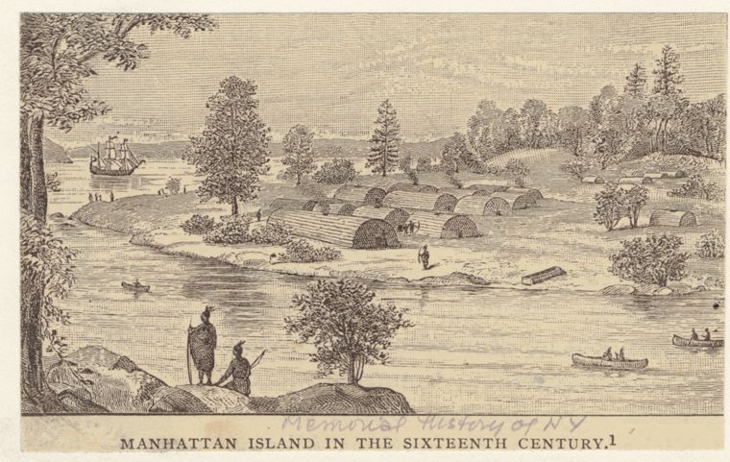

*Exhibit 2 - Lower Swedish Log Cabin, Darby Creek Vicinity (Clifton Heights), Darby, Delaware County, PA.[26]*

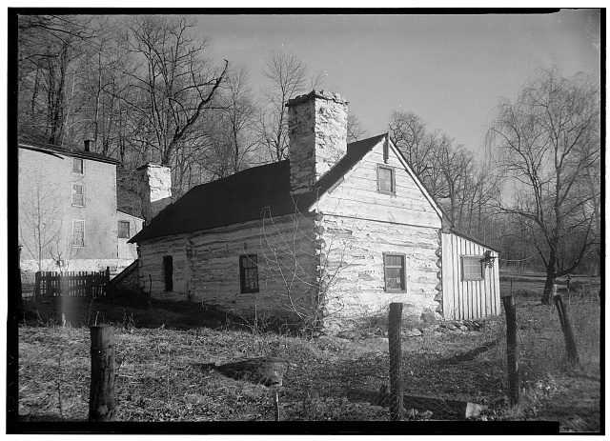

*Exhibit 3 - Whitfield House, As Seen From the South and Floor Plans.[27]*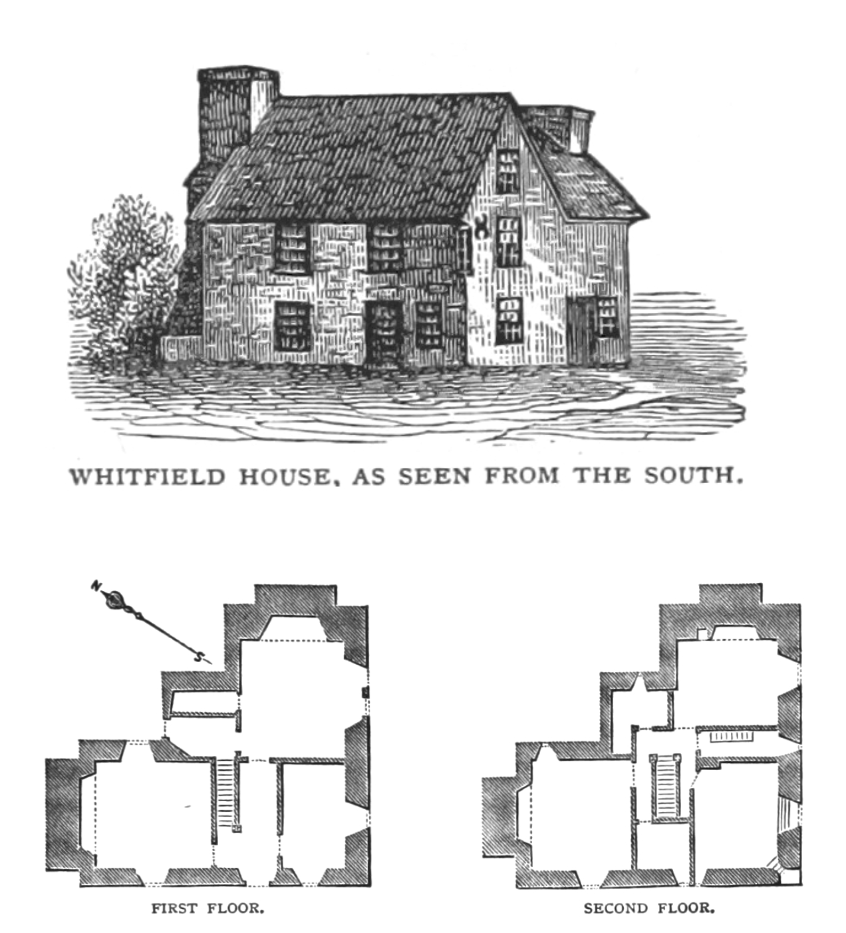

Annotated Bibliography

**Primary Sources:**

Acrelius, Israel. *A History of New Sweden: Or, The Settlements on the River Delaware*. Translated by William M. Reynolds. Philadelphia: Historical Society of Pennsylvania, 1874.  
 Acrelius was an 18th-century Swedish pastor whose account provides first-hand insight into Swedish settlement in the Delaware Valley. His reflections on the “Uproar Among the Swedes” offer a direct contemporary view of the events surrounding the Long Swede Rebellion and its impact on Swedish-English relations.

Atwater, Edward Elias. “Whitfield House, As Seen From the South and Floor Plans.” In *History of the Colony of New Haven to Its Absorption into Connecticut*, 371. New Haven, 1881.  
 Drawn from Edward Atwater’s 1881 colonial history, this floorplan and south-view engraving of the Whitfield House offers a stark visual of early English colonial domestic design. The image illustrates a multi-room, two-story home with multiple chimneys and windowed walls—features suggesting private property and spatial hierarchy.

Inclosure Consolidation Act 1801, 41 Geo. III c. 109 (1801).  
 This legal statute formalized land enclosures in England, streamlining the bureaucratic process. It provides concrete evidence of how English property ideology culminated in centralized legislation, supporting my thesis that privatization was institutionalized over centuries.

Library of Congress. *Lower Swedish Log Cabin, Darby Creek Vicinity (Clifton Heights), Darby, Delaware County, PA*. Historic American Buildings Survey, documentation compiled after 1933.<https://www.loc.gov/pictures/item/pa0412.photos.133623p/resource/>.  
 This photographic documentation of a Swedish log cabin offers direct visual evidence of Swedish vernacular architecture in colonial America. It allows for spatial and material comparison between Swedish and English settlements, reinforcing arguments about cultural and environmental adaptation.

Locke, John. *The Second Treatise of Civil Government and A Letter Concerning Toleration*. Oxford: B. Blackwell, 1948.  
 Locke’s political philosophy underpins much of the English colonial ideology. His labor theory of property and concept of the “state of nature” are central to my argument about how settler-colonialism was rationalized through Enlightenment thinking.

Newcomb, William W., Jr. *The Culture and Acculturation of the Delaware Indians*. Anthropological Papers, no. 10. Museum of Anthropology, University of Michigan, 1956.<https://delawaretribe.org/wp-content/uploads/Culture-and-Acculturation.pdf>.  
 Though compiled in the 20th century, this study draws heavily on first-hand Lenape accounts and practices. It provides detailed insight into Lenape land-use patterns, subsistence methods, and social customs, making it essential for my comparison to Swedish models.

New York Public Library. *Manhattan Island in the Sixteenth Century*. The Miriam and Ira D. Wallach Division of Art, Prints and Photographs: Picture Collection, 1892.<https://digitalcollections.nypl.org/items/510d47e1-2bbe-a3d9-e040-e00a18064a99>.  
 This 1892 illustration of pre-colonial Manhattan presents a visual counterpoint to later colonial developments. It evokes the island’s original Indigenous ecology and spatial organization, grounding the viewer in a Lenape worldview before dispossession.

Overton, Richard. *An Arrow Against All Tyrants*. October 12, 1646. constitution.org/1-History/lev/eng_lev_05.htm. Accessed June 18, 2025.  
 This radical Leveller pamphlet defends natural rights and individual liberty. It helps illustrate the ideological tension within English society over property and autonomy, reinforcing my argument that these debates shaped colonial logics.

Winstanley, Gerrard. *The True Levellers Standard Advanced: Or, The State of Community Opened, and Presented to the Sons of Men*. 1649. [www.marxists.org/reference/archive/winstanley/1649/levellers-standard.htm](http://www.marxists.org/reference/archive/winstanley/1649/levellers-standard.htm).  
 Winstanley’s manifesto lays out a vision of communal land use. It provides ideological contrast to Locke and Overton, and helps articulate the radical alternative that the English elite ultimately suppressed—mirroring the dismissal of Indigenous land systems.

### **Secondary Sources**

Clark, Gregory, and Anthony Clark. “Common Rights to Land in England, 1475–1839.” *The Journal of Economic History* 61, no. 4 (2001): 1009–1036.<https://www.jstor.org/stable/2697915>.  
 This article offers statistical and historical context for the decline of common land in England. It substantiates my claim that enclosure was widespread and normalized before Locke’s theoretical interventions.

Covart, Elizabeth. “New Sweden: A Brief History.” Penn State University Libraries, September 16, 2016.<https://libraries.psu.edu/about/collections/unearthing-past-student-research-pennsylvania-history/new-sweden-brief-history>.  
 This summary outlines the political and diplomatic strategies of the Swedish colony. It provides background for understanding how Swedish officials like Johan Printz maintained favorable Indigenous relations.

Haefeli, Evan. “The Revolt of the Long Swede: Transatlantic Hopes and Fears on the Delaware, 1669.” *Pennsylvania Magazine of History and Biography* 131, no. 1 (January 2007): 137–180.<https://journals.psu.edu/pmhb/article/view/59108/58833>.  
 Haefeli provides a rich narrative of the Long Swede rebellion, connecting local unrest to broader colonial tensions. This is one of my most important secondary sources for contextualizing the rebellion’s causes, leadership, and outcome.

Jordan-Bychkov, Terry G., and Matti E. Kaups. *The American Backwoods Frontier: An Ethnic and Ecological Interpretation*. Baltimore: Johns Hopkins University Press, 1989.  
 This ethnogeographic study helps frame the cultural distinctiveness of Swedish and Finnish settlers, including their communal land practices and environmental adaptation. It supports my argument about cultural alignment with Lenape systems.

Licht, Walter, et al. “The Original People and Their Land: Lenape Pre-History to the 18th Century.” Collaborative History, University of Pennsylvania.<https://collaborativehistory.gse.upenn.edu/stories/original-people-and-their-land-lenape-pre-history-18th-century>.  
 This source provides accessible and academically grounded information on Lenape governance, land sharing, and social organization. It reinforces my points about Lenape flexibility and communal authority structures.

Smith, Thomas M. *Enclosure & Agricultural Improvement In North-West Lincolnshire From Circa 1600 to 1850.* University of Nottingham, 2013.<https://eprints.nottingham.ac.uk/12489/1/Tom%27s_Thesis_complete_%28slimline%29.pdf>.  
 Smith’s thesis examines enclosure through detailed case studies such as the Fenlands. It offers a ground-level perspective on resistance and state enforcement, adding depth to my claim that enclosure was actively imposed.

Snatic, Jonathan. “Hunting and Gathering by the Sámi.” Sámi Culture, University of Texas at Austin.<https://www.laits.utexas.edu/sami/diehtu/siida/hunting/jonsa.htm>.  
 This ethnographic overview of Sámi life shows cultural continuity between Scandinavian settler practices and Indigenous models. It strengthens my argument about the compatibility between Swedish/Finnish and Lenape approaches to land use.

Soderlund, Jean R. *Separate Paths: Lenapes and Colonists in West New Jersey*. New Brunswick: Rutgers University Press, 2022.  
 Soderlund’s monograph is key to my analysis. She traces Lenape-European relations with nuance, offering essential evidence for the shared political and social worlds between Swedes, Finns, and Lenape peoples.

1. Locke, *Second Treatise*, V, §49.
2. Overton, *Arrow Against All Tyrants*, 1.
3. Winstanley, *True Levellers Standard*, 1.
4. Clark and Clark, “Common Rights to Land,” 1.
5. Smith, *Enclosure & Agricultural Improvement*, 18–19.
6. Locke, *Second Treatise*, V, §27.
7. Locke, *Second Treatise*, V, §28.
8. *Inclosure Consolidation Act 1801*.
9. Soderlund, *Separate Paths*, 32–37.
10. Snatic, “Hunting and Gathering by the Sámi.”
11. Soderlund, *Separate Paths*, 32.
12. New York Public Library, *Manhattan Island*.
13. Library of Congress, *Lower Swedish Log Cabin*.
14. Atwater, *Whitfield House*, 371.
15. Licht et al., “Original People and Their Land.”
16. Newcomb, *Culture and Acculturation*, 20.
17. Soderlund, *Separate Paths*, 32.
18. Haefeli, “Revolt of the Long Swede,” 138.
19. Haefeli, “Revolt of the Long Swede,” 149.
20. Acrelius, *A History of New Sweden*, 116.
21. Jordan-Bychkov and Kaups, *American Backwoods Frontier*, 72.
22. Covart, “New Sweden.”
23. Jordan-Bychkov and Kaups, *American Backwoods Frontier*, 72.
24. Locke, *Second Treatise*, V, §49.
25. New York Public Library, *Manhattan Island*.
26. Library of Congress, *Lower Swedish Log Cabin*.
27. Atwater, *Whitfield House,* 371.